Lecture#25 BottomSheet
Objectives
- BottomSheet
- Custom Button

BottomSheet:
A "bottom sheet" is a material design panel that slides up from the bottom of the screen, displaying additional content or options for the user.
In Flutter, the showModalBottomSheet() method can be used to display a bottom sheet. This method takes a BuildContext and a builder function that returns the widget tree for the bottom sheet.
By default, a bottom sheet is modal, meaning that it blocks user interaction with the rest of the app until it is dismissed. However, the isScrollControlled property can be set to true to allow the bottom sheet to scroll independently of the parent widget.
When using a bottom sheet, it's important to consider the placement of the "Close" button. One option is to include a button within the bottom sheet itself, while another option is to add a button to the parent widget that dismisses the bottom sheet.
Example code:
import 'package:flutter/material.dart';

void main() async {
WidgetsFlutterBinding.ensureInitialized();

runApp(MaterialApp(
home: ProductListPage(),
));
}

class ProductListPage extends StatefulWidget {
const ProductListPage({Key? key}) : super(key: key);

@override
_ProductListPageState createState() => _ProductListPageState();
}

class _ProductListPageState extends State<ProductListPage> {
List<String> _products = [
'Product 1',
'Product 2',
'Product 3',
'Product 4',
'Product 5',
];

@override
Widget build(BuildContext context) {
return Scaffold(
appBar: AppBar(
title: Text('Product List'),
actions: [
IconButton(
onPressed: () {
showModalBottomSheet(
context: context,
isScrollControlled: true,
builder: (BuildContext context) {
return SingleChildScrollView(
child: Container(
padding: EdgeInsets.only(
bottom: MediaQuery.of(context).viewInsets.bottom,
),
child: Column(
mainAxisSize: MainAxisSize.min,
children: [
Container(
width: double.infinity,
height: 50,
color: Colors.grey[300],
child: Center(
child: Text(
'Filter Options',
style: TextStyle(fontSize: 20),
),
),
),
ListTile(
title: Text('Option 1'),
trailing: Checkbox(
value: true,
onChanged: (bool? value) {},
),
),
ListTile(
title: Text('Option 2'),
trailing: Checkbox(
value: false,
onChanged: (bool? value) {},
),
),
ListTile(
title: Text('Option 3'),
trailing: Checkbox(
value: true,
onChanged: (bool? value) {},
),
),
ListTile(
title: Text('Option 4'),
trailing: Checkbox(
value: false,
onChanged: (bool? value) {},
),
),
SizedBox(height: 16),
ElevatedButton(
onPressed: () {
// Apply the filters and update the product list
Navigator.of(context).pop();
},
child: Text('Apply Filters'),
),
],
),
),
);
},
);
},
icon: Icon(Icons.filter_list),
),
],
),
body: ListView.builder(
itemCount: _products.length,
itemBuilder: (BuildContext context, int index) {
return ListTile(
title: Text(_products[index]),
subtitle: Text('Price: \$${index + 1}0'),
leading: CircleAvatar(
child: Text('${index + 1}'),
),
trailing: IconButton(
onPressed: () {
// Add to cart
},
icon: Icon(Icons.add_shopping_cart),
),
);
},
),
);
}
}
Screenshot:
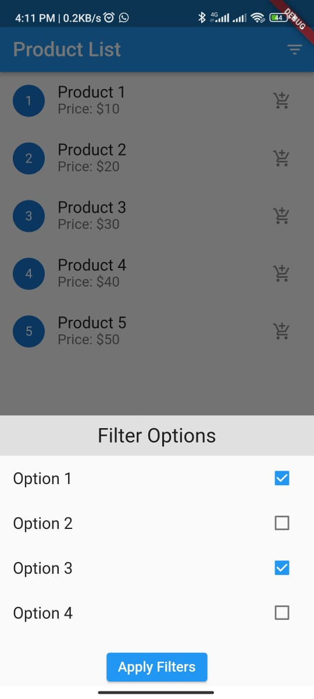
Custom Button:
You can create a custom button in Flutter using InkWell widget for handling the button press and ink splash effects, and the Container widget for defining the button's size, color, and shape.
Example:

import 'package:flutter/material.dart';

void main() async {
WidgetsFlutterBinding.ensureInitialized();

runApp(MaterialApp(
home: MyApp(),
));
}

class MyApp extends StatelessWidget {
const MyApp({super.key});

@override
Widget build(BuildContext context) {
return Scaffold(
body: Center(
child: CustomButton(
onPressed: () {},
text: "Custom Button",
),
),
);
}
}

class CustomButton extends StatelessWidget {
final String text;
final VoidCallback onPressed;

const CustomButton({required this.text, required this.onPressed});

@override
Widget build(BuildContext context) {
return InkWell(
onTap: onPressed,
child: Container(
padding: EdgeInsets.symmetric(vertical: 12.0, horizontal: 24.0),
decoration: BoxDecoration(
color: Colors.blue, // Set custom button color here
borderRadius: BorderRadius.circular(20.0), // Set rounded border here
),
child: Text(
text,
style: TextStyle(
color: Colors.white,
fontSize: 18.0,
fontWeight: FontWeight.bold,
),
),
),
);
}
}

Screenshot:
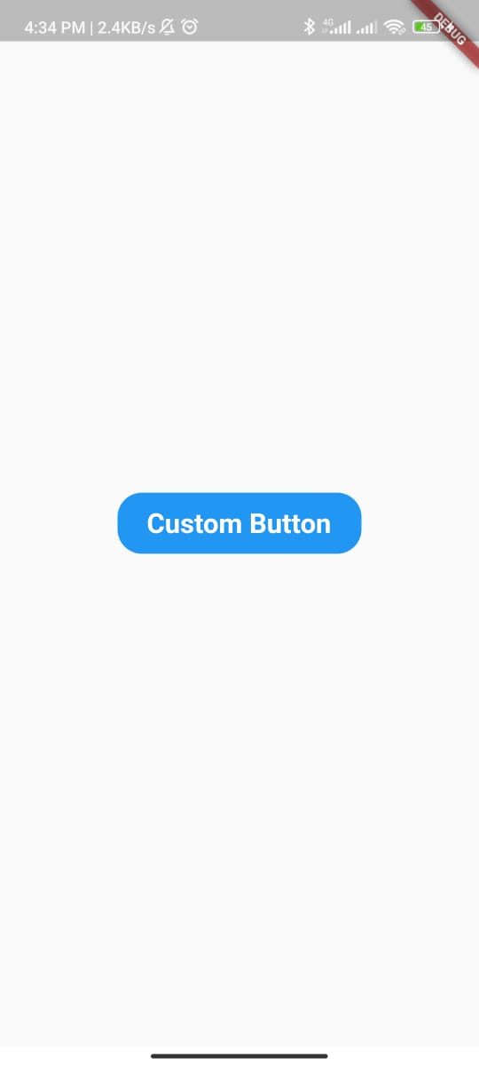

Lecture#26 Animations
Objectives
- AnimatedContainer
- AnimatedOpacity
- AnimatedPositioned
- CustomAnimation

AnimatedContainer:
The AnimatedContainer widget is used to animate the changes in height and color.
import 'package:flutter/material.dart';

void main() {
runApp(MaterialApp(
home: MyApp(),
));
}

class MyApp extends StatelessWidget {
const MyApp({super.key});

@override
Widget build(BuildContext context) {
return Scaffold(
body: Center(child: ExampleWidget()),
);
}
}

class ExampleWidget extends StatefulWidget {
@override
_ExampleWidgetState createState() => _ExampleWidgetState();
}

class _ExampleWidgetState extends State<ExampleWidget> {
bool _isExpanded = false;

@override
Widget build(BuildContext context) {
return GestureDetector(
onTap: () {
setState(() {
_isExpanded = !_isExpanded;
});
},
child: AnimatedContainer(
duration: Duration(milliseconds: 500),
curve: Curves.easeInOut,
height: _isExpanded ? 200 : 100,
color: _isExpanded ? Colors.blue : Colors.red,
child: Center(
child: Text(
'Tap me!',
style: TextStyle(color: Colors.white),
),
),
),
);
}
}

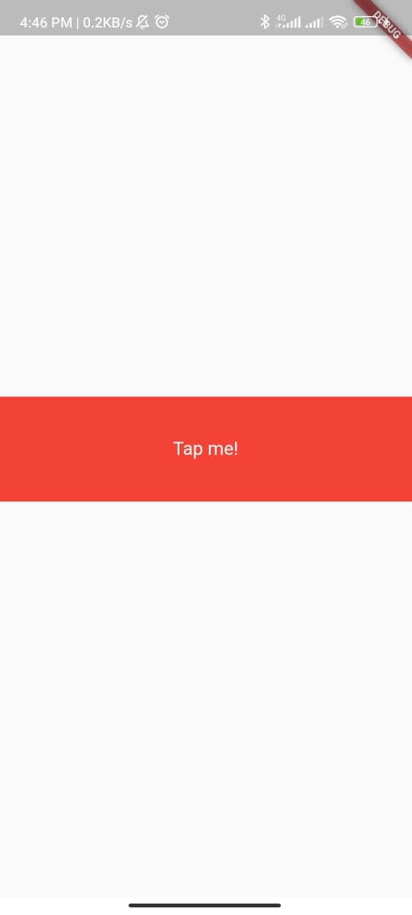

AnimatedOpacity:
The AnimatedOpacity widget is used to animate the changes in opacity.
import 'package:flutter/material.dart';

void main() {
runApp(MaterialApp(
home: MyApp(),
));
}

class MyApp extends StatelessWidget {
const MyApp({super.key});

@override
Widget build(BuildContext context) {
return Scaffold(
body: Center(child: ExampleWidget()),
);
}
}

class ExampleWidget extends StatefulWidget {
@override
_ExampleWidgetState createState() => _ExampleWidgetState();
}

class _ExampleWidgetState extends State<ExampleWidget> {
bool _isVisible = true;

@override
Widget build(BuildContext context) {
return GestureDetector(
onTap: () {
setState(() {
_isVisible = !_isVisible;
});
},
child: AnimatedOpacity(
duration: Duration(milliseconds: 500),
curve: Curves.easeInOut,
opacity: _isVisible ? 1.0 : 0.0,
child: Container(
height: 100,
width: 100,
color: Colors.blue,
child: Center(
child: Text(
'Tap me!',
style: TextStyle(color: Colors.white),
),
),
),
),
);
}
}

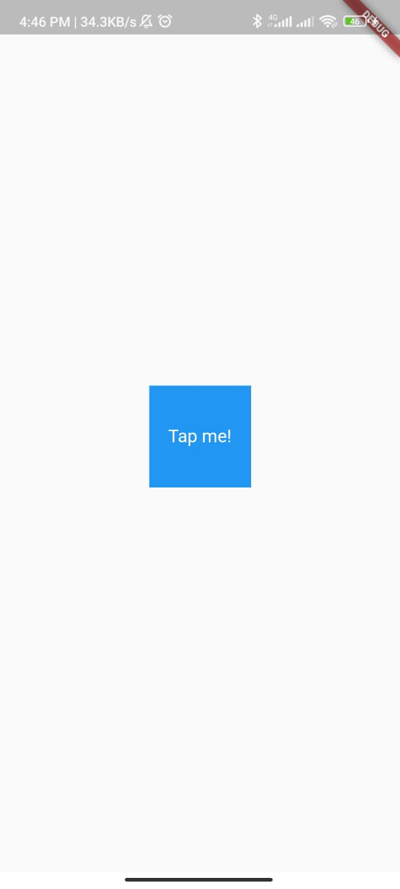
AnimatedPositioned:
The AnimatedPositioned widget is used to animate the changes in position.
import 'package:flutter/material.dart';

void main() {
runApp(MaterialApp(
home: MyApp(),
));
}

class MyApp extends StatelessWidget {
const MyApp({super.key});

@override
Widget build(BuildContext context) {
return Scaffold(
body: Center(child: ExampleWidget()),
);
}
}

class ExampleWidget extends StatefulWidget {
@override
_ExampleWidgetState createState() => _ExampleWidgetState();
}

class _ExampleWidgetState extends State<ExampleWidget> {
bool _isMoved = false;

@override
Widget build(BuildContext context) {
return GestureDetector(
onTap: () {
setState(() {
_isMoved = !_isMoved;
});
},
child: Stack(
children: [
AnimatedPositioned(
duration: Duration(milliseconds: 500),
curve: Curves.easeInOut,
left: _isMoved ? 100 : 0,
top: _isMoved ? 100 : 0,
child: Container(
height: 100,
width: 100,
color: Colors.blue,
),
),
],
),
);
}
}

CustomAnimation:
To create a custom animation in Flutter, you can use the AnimationController and Animation classes. Here's an example of how you can create a simple animation that moves a widget from one position to another:
import 'package:flutter/material.dart';

void main() {
runApp(MaterialApp(
home: MyApp(),
));
}

class MyApp extends StatelessWidget {
const MyApp({super.key});

@override
Widget build(BuildContext context) {
return Scaffold(
body: Center(child: MyCustomAnimation()),
);
}
}
class MyCustomAnimation extends StatefulWidget {
@override
_MyCustomAnimationState createState() => _MyCustomAnimationState();
}

class _MyCustomAnimationState extends State<MyCustomAnimation>
with SingleTickerProviderStateMixin {
AnimationController? _controller;
Animation<Offset>? _animation;

@override
void initState() {
super.initState();
_controller = AnimationController(
vsync: this,
duration: Duration(seconds: 2),
);
_animation = Tween<Offset>(
begin: Offset.zero,
end: Offset(1.0, 1.0),
).animate(_controller!);

_controller!.forward();
}
@override
Widget build(BuildContext context) {
return SlideTransition(
position: _animation!,
child: Container(
width: 100,
height: 100,
color: Colors.blue,
),
);
}
@override
void dispose() {
_controller!.dispose();
super.dispose();
}
}

